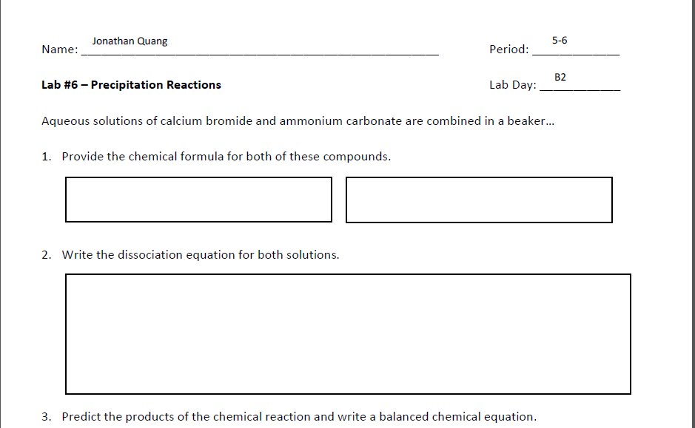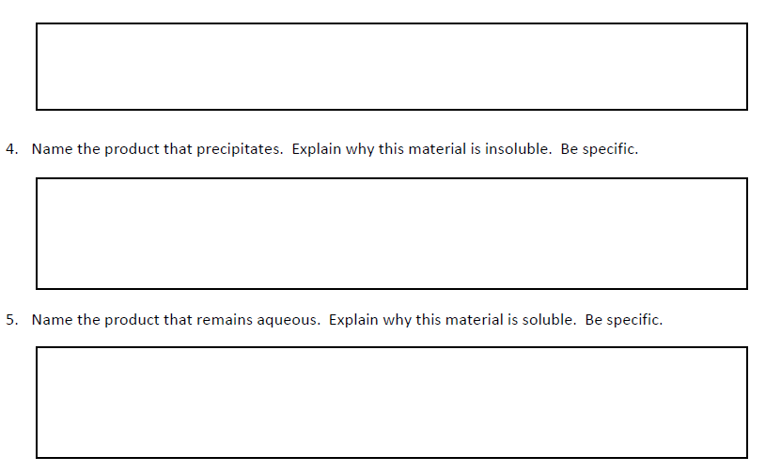

The product that precipitates is ammonium bromide because the halide, bromine, always results in soluble compounds, and the exception does not apply. Ag, Pb, and Hg are not involved in this equation, therefore the exception does not apply

The product that precipitates is calcium carbonate because the carbonate ion always forms an insoluble compound and the exception does not apply. Ca is neither a group 1 ion or ammonium.

CaBr2 + (NH4)2CO3 → CaCO3 + 2(NH4)Br

CaBr2 + (NH4)2CO3 → Ca+2 + 2Br -  + 2(NH4)+  + (CO3)-2

(NH4)2CO3

CaBr2